JIO with HC-06 bluetooth for Linux installation steps

Hardware/software
- HC-06 with firmware version hc01.comV2.0
- FT232RL FTDI adapter
- Linux Mint 22
- Arduino IDE (software, not the board) or other serial communications program

1. Connect the HC-06 to the FTDI adapter
HC-06 Adapter
RX TX
TX RX
VCC IN 5V OUT
GND GND

2. Configure HC-06 with Arduino IDE serial monitor

Connect the FTDI adapter to the PC USB port and start Arduino IDE.
Set serial monitor to "no line ending" and "9600 baud"
Enter "AT" and response should be "OK"
If not then the firmware may require a "Both NL + CR" or the device is configured for a different baud rate.

Enter "AT+BAUD8" and response should be "OK115200"

If not then try "AT+UART=115200,1,0" and response should be "OK"

Enter "AT+NAMEHC-06A" and response should something like "Oksetname"

You can also use minicom instead of the Arduino IDE. Then you have to copy/paste the commands or use a script. The HC-06 expects the full command text to be sent within 1 second.

3. Pair device with Linux PC

The HC-06 uses an older bluetooth 2.0 standard and may not show up in the Linux bluetooth manager GUI. Use the commandline tool bluetoothctl to pair the device with following commands:
scan on --> a list of available bluetooth devices, lookup the HC-06A
pair xx:xx:xx:xx:xx (replace xx with HC-06A MAC address)
password: 1234
exit
4. Link device to serial port in the GUI

In the bluetooth manager, enable bluetooth and connect the HC-06A to a serial port.
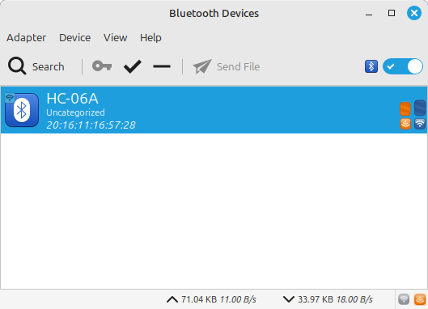

Optional loopback test if the bluetooth adapter works correctly: connect the tx and rx pin and test with “minicom -D /dev/rfcomm0” if characters typed echo to the screen.

5. JIO usage

Wire the HC-06 to the MSX gpio port 2:

HC-06 MSX
RX pin 6
TX pin 1
VCC IN pin 5
GND pin 9

Officially the HC-06 requires 3.3V on the RX input which can be accomplished with a 1K/2K resistor voltage divider to lower the MSX 5V level to 3.3V. I’ve left this out because of the low current on the joystick ports and it doesn’t work with my VG8010.

In the JIO server app connect to the rfcomm0 device and reboot the MSX:
